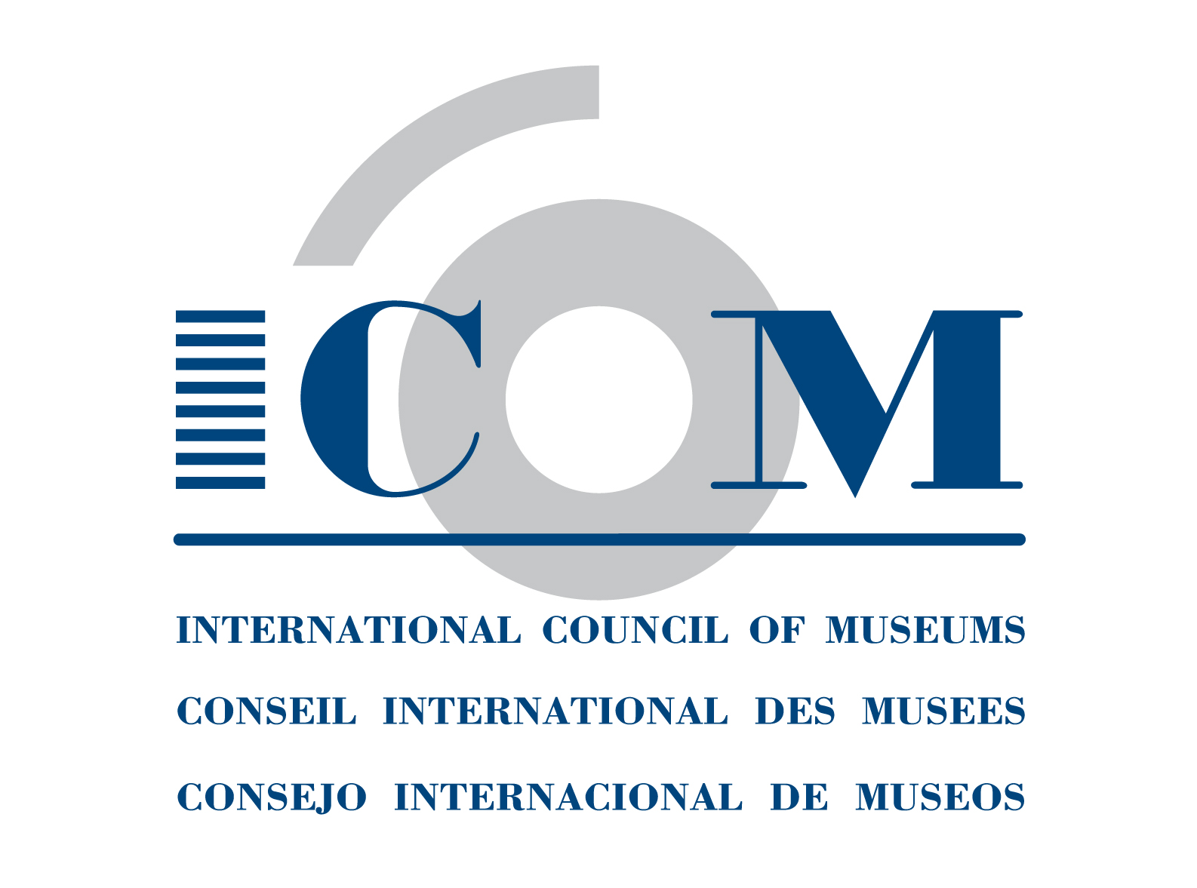  Tel + 33 (0) 1 47 34 05 00  Fax + 33 (0) 1 43 06 78 62  E-mail: membership@icom.museum  http://icom.museum | INDIVIDUAL MEMBERSHIP APPLICATION FORM  Please complete legibly and return to your National Committee  http://icom.museum/the-committees/national-committees

First name: Last name:

Title: Mr/Mrs/Ms/Prof/Dr Gender: Female/Male Date of birth:
^{(Please circle your answer)} ^{(Please circle your answer)} ^{(DD/MM/YY)}
Your institution or the last institution where you worked-to be used as main contact information : q Yes q No

Name: Institution’s website: Your position:

Professional:

City: Postal code: Country:

Email: Tel: Fax:
(Please indicate country & area code) (Please indicate country & area code)

Your personal information -to be used as main contact information: q Yes q No

Address:

City: Postal code: Country:

Email: Tel: Fax:
(Please indicate country & area code) (Please indicate country & area code)

Category of membership: q Regular (voting) q Retired Professional* (voting) q Associate (voting)
q Student* (non-voting) q Contributor (voting) q Supporting (non-voting)
^{*Submit supporting document}
Language for communication (tick one): q English q French q Spanish

If you wish to become a member of an International Committee with full voting rights, please choose one:

Archaeology & History (ICMAH)
Architecture & Museum Techniques (ICAMT)
Arms & Military History (ICOMAM)
Audio-visual & New Technologies (AVICOM) Conservation (ICOM-CC)
Decorative Arts and Design (ICDAD)
Collecting (COMCOL)
COSTUME
Documentation (CIDOC)
Education & Cultural Action (CECA)
Egyptology (CIPEG)
Ethnography (ICME)
Exhibition Exchange (ICEE)
Fine Arts (ICFA)
GLASS
Historic House Museums (DEMHIST)
Literary Museums (ICLM)
Management (INTERCOM)
Marketing & Public Relations (MPR)
Memorial Museums (IC MEMO)
Money & Banking Museums (ICOMON)
Museology (ICOFOM)
Museum Security (ICMS)
Museums of Cities (CAMOC)
Musical Instruments (CIMCIM)
Natural History (NATHIST)
Regional Museums (ICR)
Science & Technology (CIMUSET)
Training of Personnel (ICTOP)
University Museums (UMAC)

For more information on the ICOM International Committees, please see http://icom.museum/the-committees/international-committees

Committee chosen (only one):
You can indicate up to three other committees you have an interest in:

Note: the above information will be automatically processed to ensure your receipt of services from ICOM. In conformity with the French law on Informatics & Civil Liberties (Jan. 6, 1978, rev.), you have the right of access and to modify the information that concerns you.

I authorise ICOM to publish my data on its website (access restricted to ICOM officers and Committees): q Yes q No
I authorise ICOM to diffuse my data to non-ICOM third parties: q Yes q No

Please complete, date and sign the following declaration:
I, , declare that I am eligible for membership of the International Council of Museums (ICOM) and wish to become a member of ICOM. I do not engage in dealing (i.e. buying and selling for profit) in the field of cultural property and accept the ICOM Code of Ethics for Museums.

DATE:__________________________________ SIGNATURE:_______________________________________________

October 2014

